**General Insurance**

**Patient Health**

**Use Case Document**

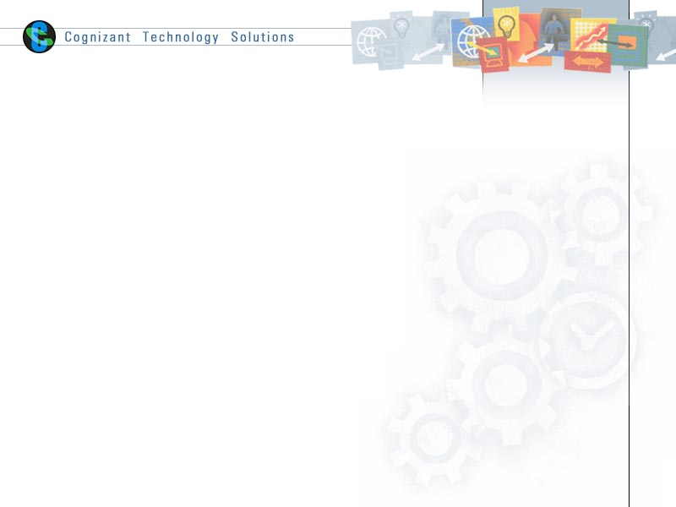

|  |  |  |  |
| --- | --- | --- | --- |
|  | Prepared By / Last Updated By | Reviewed by | Approved By |
| Name | Person 1 | Person 2 | Person 3 |
| Role | Team Member | Team Member | Scrum Master |
| Signature |  |  |  |
| Date |  |  |  |

Table of Contents

1.0 Introduction 3

1.1 Purpose & Scope of the document 3

1.2 Intended Audience 3

1.3 Use case ‘User Registration’ 3

1.3.1 Use case attributes 3

1.3.2 Use Case Model 4

1.3.3 Business Rules 4

1.3.4 UI Requirements 4

1.3.5 UI Field Validations 5

1.4 Use case ‘User Credential Authentication’ 6

1.4.1 Use case attributes 6

1.4.2 Use Case Model 7

1.4.3 Business Rules 7

1.4.4 UI Requirements 7

2.0 Database Design 8

2.1 Tables Structure 8

3.0 Change Log 10

# Introduction

## Purpose & Scope of the document

The purpose of this Use case document is to systematically capture requirements for the project and the system to be developed in terms of use cases. Functional use cases are captured in this document. It also serves as the input for the project scoping.

The scope of this document is limited to addressing the use cases from a user, quality, and non-functional perspective.

## Intended Audience

Each member of the project team

## Use case ‘User Registration’

### Use case attributes

**Use Case Description:**

This use case deals with the capture of user details. The ‘admin’ here shall be the operator of the system and will be keying in the plane, pilot and hangar information into the system. ‘manager’ shall

**Scope:**

* Admin registration
* Manager registration

**Actors:**

* Admin
* Manager

**Trigger:**

Click ‘Submit’ button in the ‘User Registration’ page

**Pre-Condition:**

User being able to access the homepage & get redirected to the ‘User Registration’ page upon click of ‘New User? Create an account’ link.

**Post Condition:**

User is in the enrollment page & submit details

**Flow of Events:**

User at homepage 🡪 Click ‘Register if new’ link 🡪 User is in the enrollment page 🡪 User details are submitted and added onto the database

**Primary Scenario:**

A new user – is able to click ‘New User? Create an account’ link and able to provide his details and get enrolled in the system.

### Use Case Model

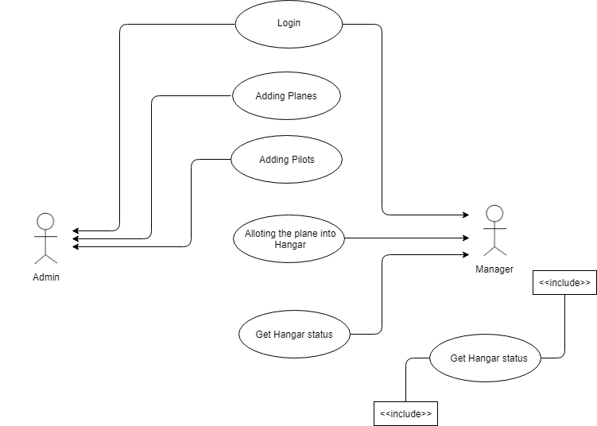

### Business Rules

Business rules should be defined using the following attributes: -

* When the user clicks on the registration link, it should re-direct to registration form.
  + - User needs to fill some of the basic attributes/fields as mentioned below in requirement: First Name, Last Name, Age, Gender, Contact Number, Email Id, Password, date of birth, and verify reCaptcha
* Clicking ‘Submit’ should validate the datatype constraints for each field
* Post-successful field level validation, save the information in the database
* Upon saving the information in the database, display the message ‘Your details are submitted successfully’.

### UI Requirements

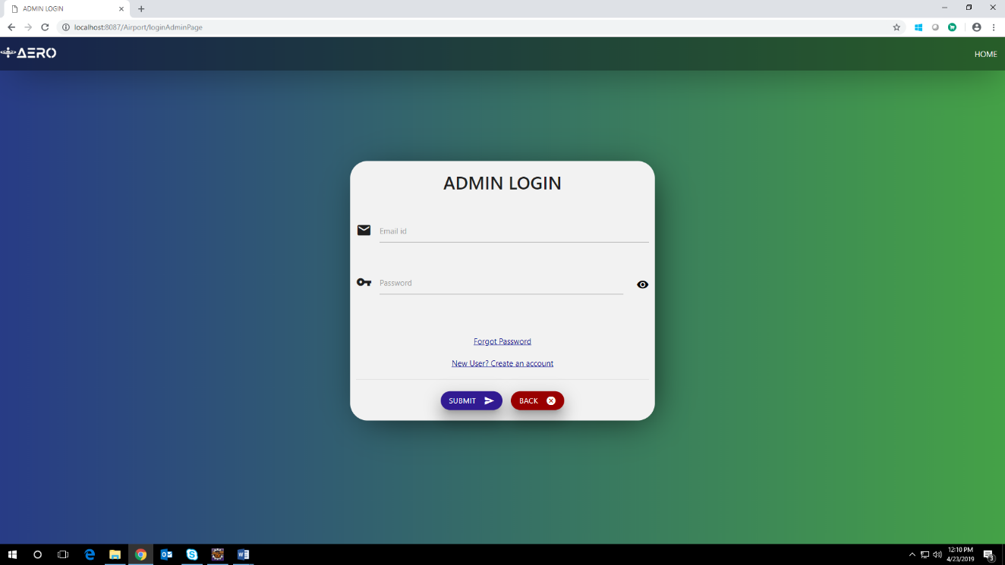

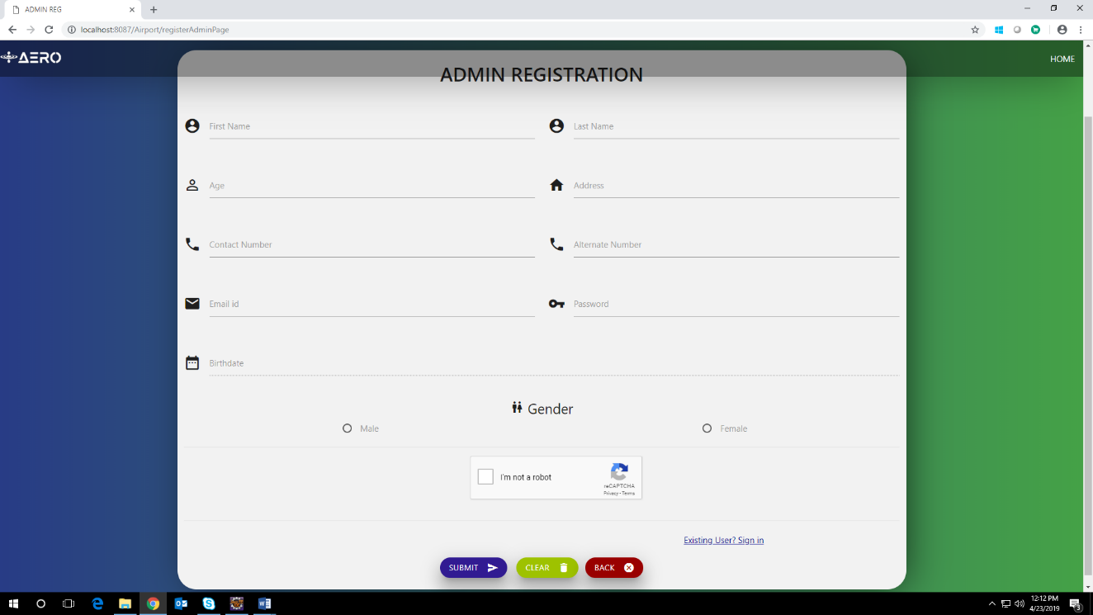

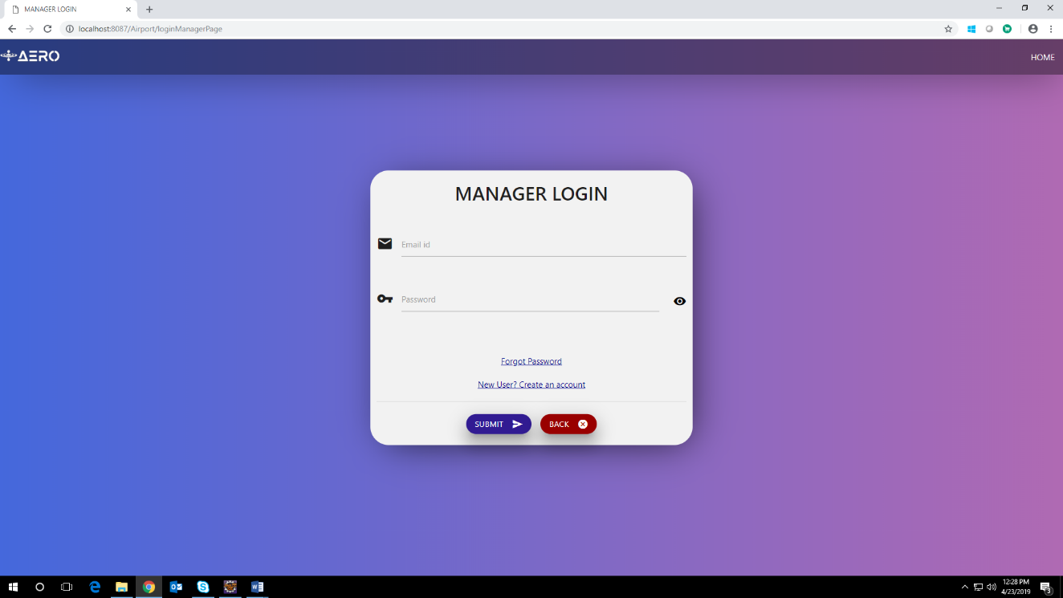

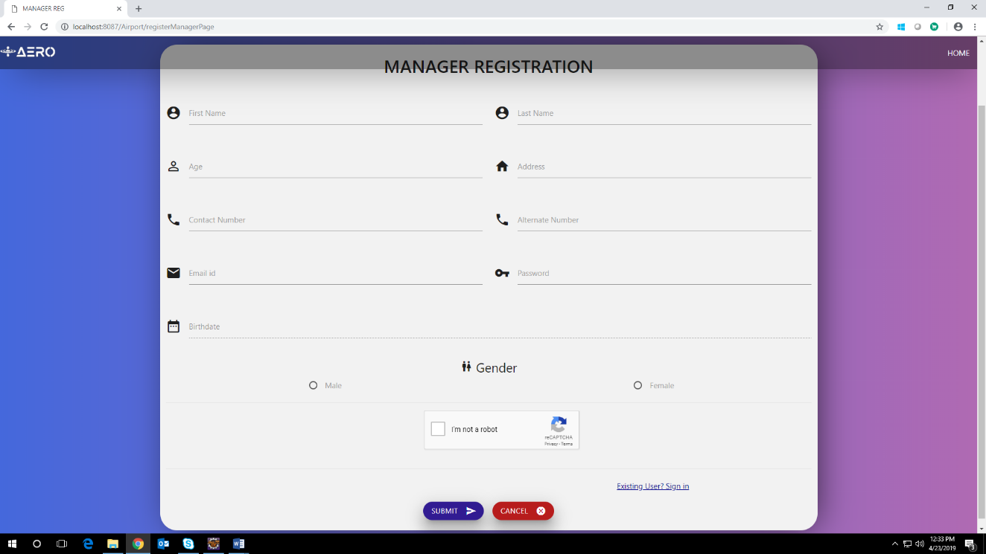

### UI Field Validations

Please refer to the below requirements for field level validations:

* All fields except alternate number are mandatory.
* EmailId should be less than 30 chars. Password should have minimum 8 chars maximum 20 characters, no space & can contain special characters (@,#,%,*,&)
* The Email ID format must be checked. (For ex. [test@testmail.com](mailto:test@testmail.com).)
* Phone Number must be of 10 digits’ length

# Database Design

## Tables Structure

**TBL_USER:**

|  |  |  |  |
| --- | --- | --- | --- |
| **Column Name** | **Data Type** | **Length** | **Nulls** |
| ID | NUMBER | 8 | N |
| FIRSTNAME | VARCHAR2 | 50 | N |
| LASTNAME | VARCHAR2 | 50 | N |
| AGE | NUMBER | 2 | N |
| GENDER | VARCHAR2 | 6 | N |
| ADDRESS | VARCHAR2 | 60 | N |
| DOB | VARCHAR2 | 15 | N |
| CONTACTNUMBER | NUMBER | 10 | N |
| ALTNUMBER | NUMBER | 10 | Y |
| EMAILID | VARCHAR2 | 30 | N |
| PASSWORD | VARCHAR2 | 30 | N |
| USERTYPE | VARCHAR2 | 10 | N |
| STATUS | VARCHAR2 | 10 | N |

**TBL_PILOT:**

|  |  |  |  |
| --- | --- | --- | --- |
| **Column Name** | **Data Type** | **Length** | **Nulls** |
| PILOTID | NUMBER | 8 | N |
| LICENSENUMBER | NUMBER | 7 | N |
| ADDRESS | VARCHAR2 | 60 | N |
| CITY | VARCHAR2 | 10 | N |
| STATE | VARCHAR2 | 15 | N |
| ZIPCODE | NUMBER | 6 | N |
| SSN | NUMBER | 9 | N |

**TBL_OWNER:**

|  |  |  |  |
| --- | --- | --- | --- |
| **Column Name** | **Data Type** | **Length** | **Nulls** |
| ID | NUMBER | 8 | N |
| FIRSTNAME | VARCHAR2 | 50 | N |
| LASTNAME | VARCHAR | 50 | N |
| CONTACTNUMBER | NUMBER | 10 | N |
| EMAILID | VARCHAR2 | 30 | N |

**TBL_PLANE:**

|  |  |  |  |
| --- | --- | --- | --- |
| **Column Name** | **Data Type** | **Length** | **Nulls** |
| PLANEID | NUMBER | 8 | N |
| OWNERID | NUMBER | 8 | N |
| PLANETYPE | VARCHAR2 | 10 | N |
| PLANECAPACITY | NUMBER |  | N |
| PLANENUMBER | VARCHAR2 | 7 | N |

**TBL_HANGAR:**

|  |  |  |  |
| --- | --- | --- | --- |
| **Column Name** | **Data Type** | **Length** | **Nulls** |
| HANGARID | NUMBER | 8 | N |
| MANAGERID | NUMBER | 8 | N |
| CITY | VARCHAR2 | 10 | N |
| STATE | VARCHAR2 | 15 | N |
| ZIPCODE | VARCHAR2 | 6 | N |

**TBL_HANGARSTATUS:**

|  |  |  |  |
| --- | --- | --- | --- |
| **Column Name** | **Data Type** | **Length** | **Nulls** |
| HANGARID | NUMBER | 8 | N |
| PLANEID | NUMBER | 8 | Y |
| MANAGERID | NUMBER | 8 | N |
| STATUS | VARCHAR2 | 8 | N |
| OCCUPIEDFROM | VARCHAR2 | 15 | N |
| OCCUPIEDTO | VARCHAR2 | 15 | N |
| AVAILABLEFROM | VARCHAR2 | 15 | N |
| AVAILABLETO | VARCHAR2 | 15 | N |

# Change Log

|  |  |
| --- | --- |
| Version Number | Changes made |
| V1.0 | This is the first version and the final version. It includes the technical and functional details of the application including the table structure |